PROJECT:

Digital Diary CRUD Organizer

NAME: | PRACHI SANJEEV VERMA
REG NO: | 25BSA10117
SLOT: | C21+F11+F12
TEACHER: | DR G.GANESAN

- Abstract

A Digital Diary and CRUD Organizer is a lightweight personal information management system designed to record, store, and organize daily activities, notes, and reminders. It allows users to Create, Read, Update, and Delete (CRUD) entries with ease, providing a structured and secure alternative to traditional handwritten diaries. The system integrates features such as timestamping, categorization, and quick search to improve usability and retrieval efficiency. By using a simple user interface and a reliable backend database, the organizer ensures data consistency and accessibility across sessions. This digital approach enhances productivity, reduces manual effort, and supports better planning and reflection. The project demonstrates the practical application of CRUD operations in real-world personal management tools.

Problem Definition

In today’s fast-paced environment, individuals struggle to maintain and organize their daily activities, notes, tasks, and personal records using traditional paper diaries. Handwritten diaries are prone to loss, damage, lack searchability, and make editing or updating information difficult. There is also no efficient way to categorize entries, retrieve past records quickly, or ensure data integrity over time.

To address these limitations, there is a need for a Digital Diary system that enables users to efficiently Create, Read, Update, and Delete (CRUD) their daily entries in a structured and user-friendly digital platform. The system should provide secure storage, easy navigation, timestamped records, and quick retrieval to improve productivity and personal organization.

Objectives

1. To develop a digital platform that allows users to efficiently create, view, edit, and delete their daily diary entries using CRUD operations.

2. To provide secure and organized data storage with proper categorization, timestamps, and fast retrieval of past records.

3. To design a simple, user-friendly interface that improves daily planning, note-taking, and overall personal productivity.

4. To ensure data consistency and reliability through a well-structured backend database and effective system management.

Design & Architecture

A Digital Diary CRUD Organiser can be designed using a top-down design approach, where the system is first viewed as a whole and then broken down into smaller modules. At the highest level, the system is divided into major functions such as Create, Read, Update, and Delete entries. Each of these functions is then further divided into sub-modules like input handling, data validation, storage operations, and display formatting. This structured breakdown helps in organising the design clearly, simplifying implementation, and ensuring every feature is developed systematically. The final architecture follows a clean modular design where each component performs a specific task and works together to form a complete diary management system..

Work Of All Functions
1. createEntry()

Creates a new diary note.

Saves the title, date, and content as a new record.

2. readEntry()

Opens and displays a specific diary entry.

Shows full details like title, date, and message.

3. updateEntry()

Edits an existing diary entry.

Updates and replaces the old information with new content.

4. deleteEntry()

Removes a diary entry permanently.

Frees storage by deleting the selected note.

5. listAllEntries()

Displays all saved diary entries in a list.

Helps the user quickly browse all notes.

6. searchEntries()

Searches notes by keyword.

Returns only entries containing the searched word.

7. sortEntries()

Sorts diary entries by date, title, or latest update.

Helps organise notes for quick viewing.

8. saveToStorage()

Saves all diary data to file/database.

Ensures data is not lost when the app closes.

9. loadFromStorage()

Loads saved diary entries when the app starts.

Restores previous user data.

10. loginUser()

Verifies username and password.

Allows only authenticated users to access the diary.

11. logoutUser()

Ends the user session securely.

Prevents unauthorized access after use.

12. registerUser()

Creates a new user account.

Stores credentials for future login.

Implementation (Key Code Snippets)

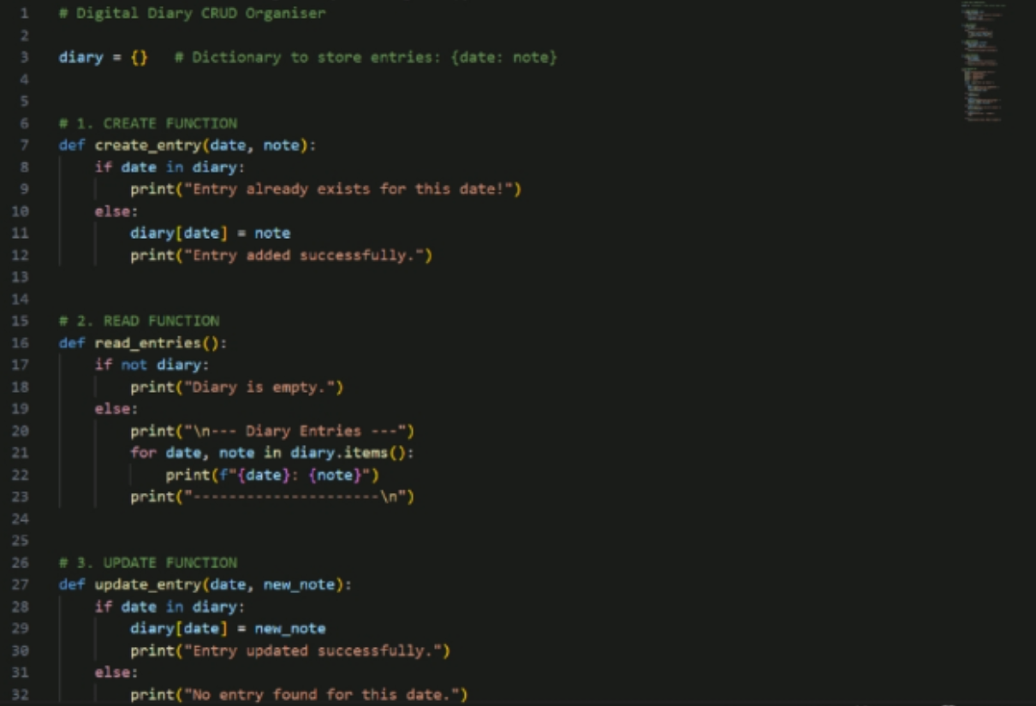
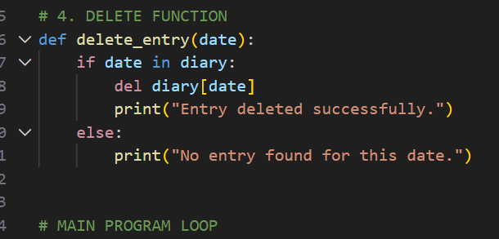

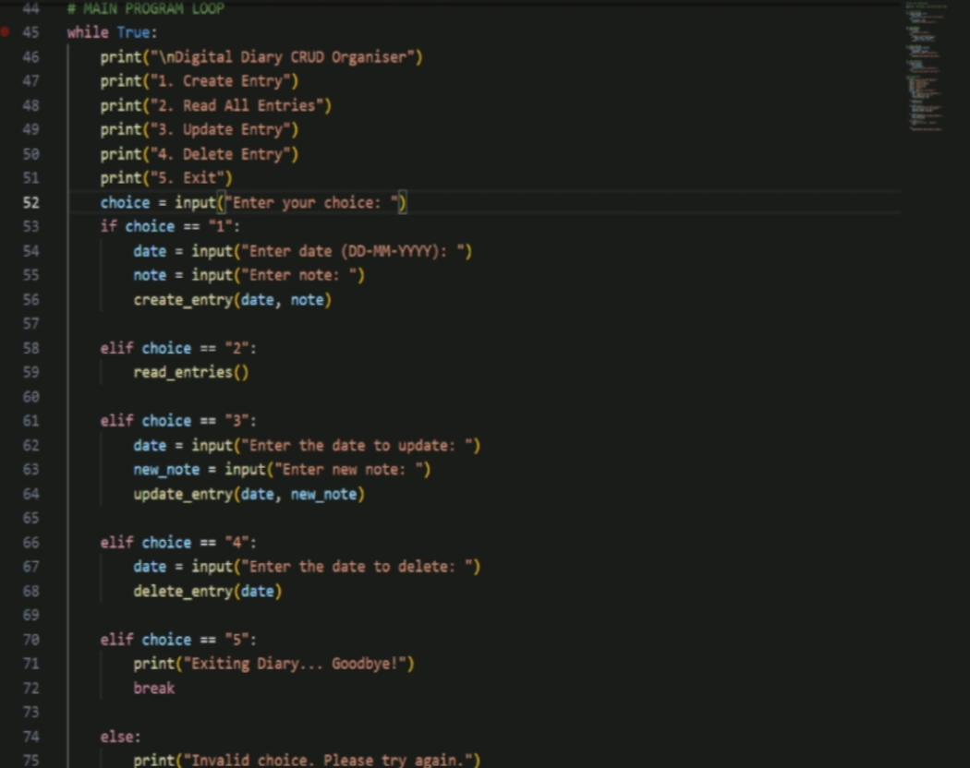
7.Inputs and outputs:

If choice is 1:
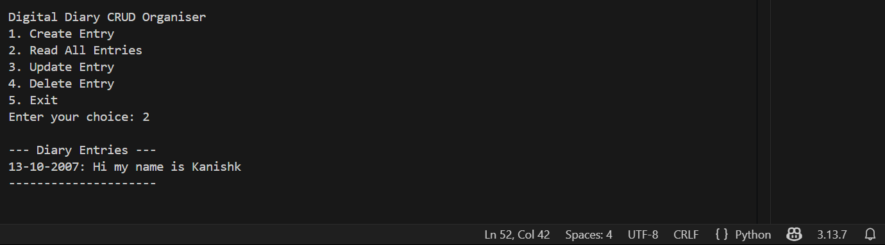
If choice is 2:

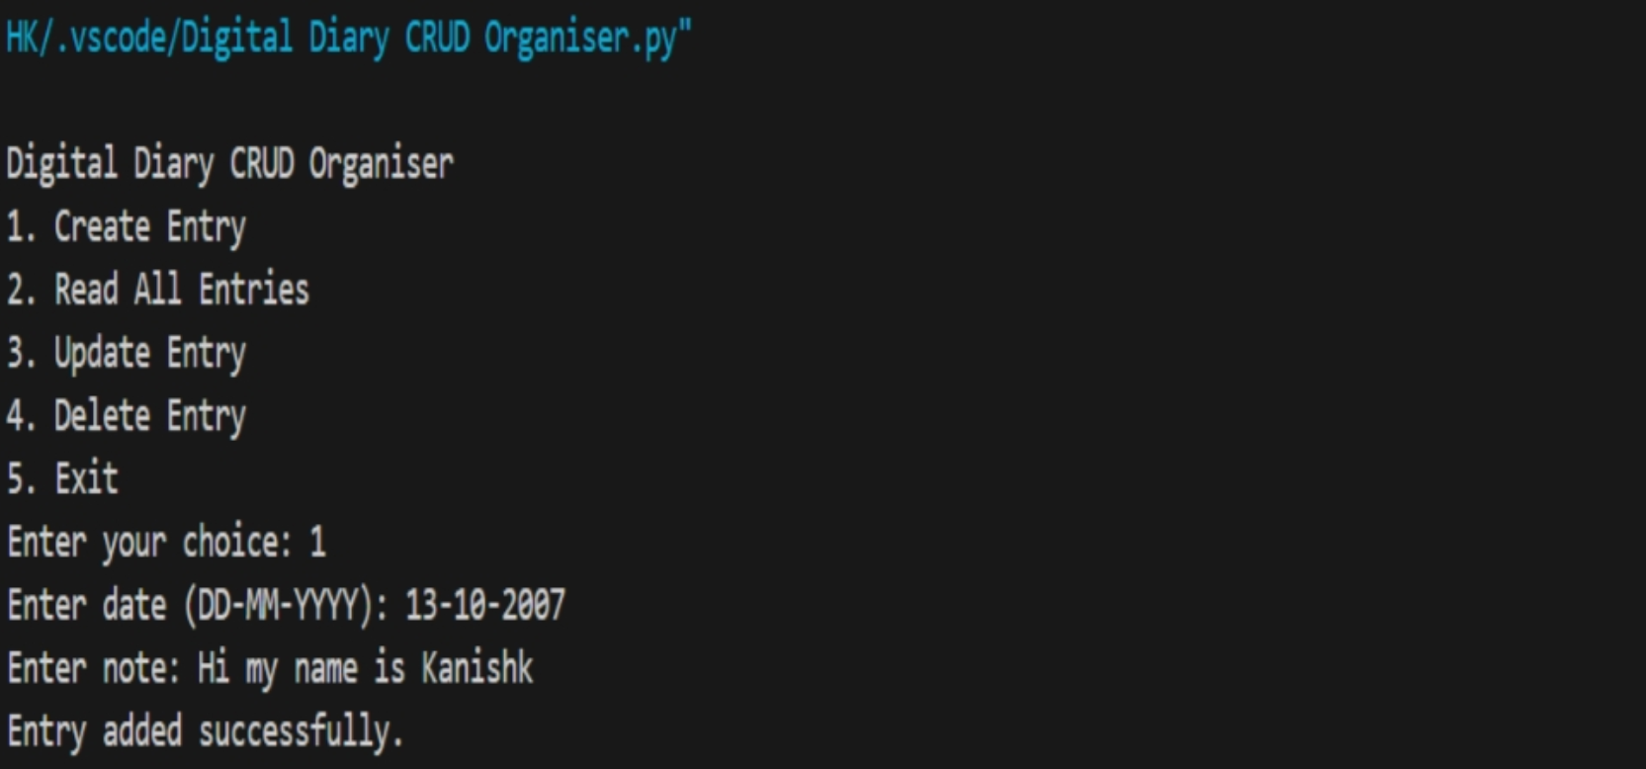
If choice is 3:

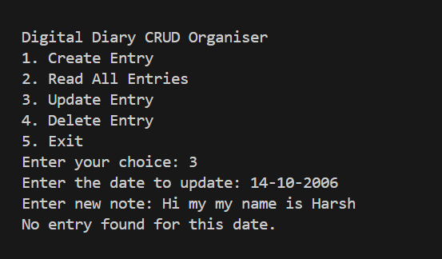

If choice is 4:

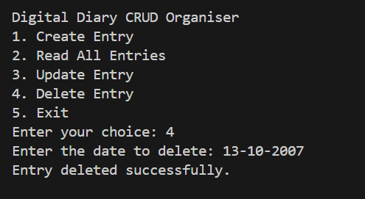

If choice is 5:

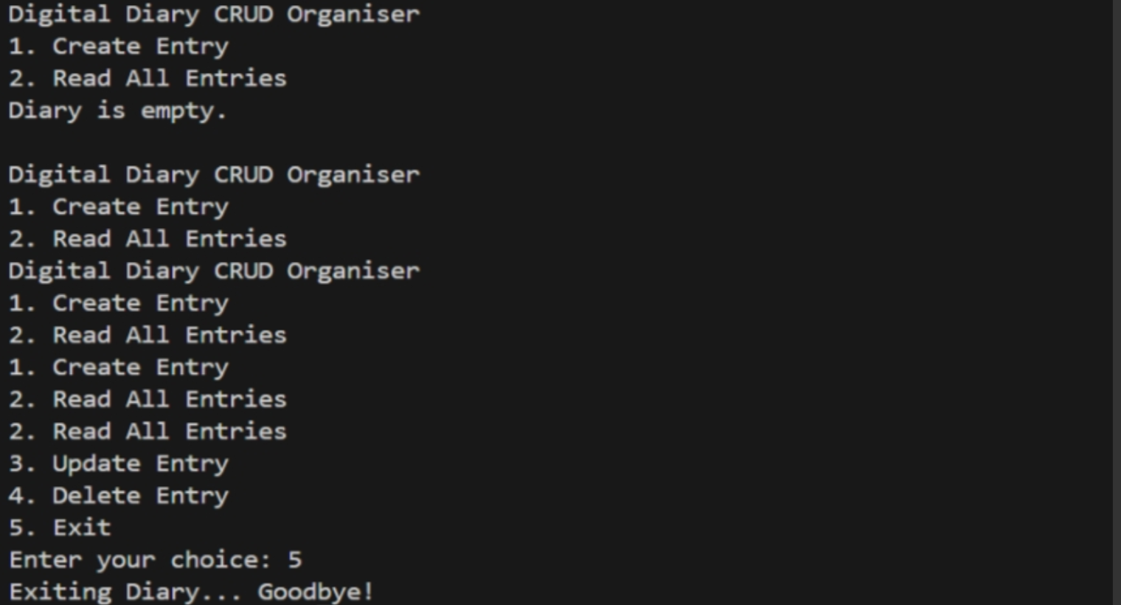

If choice is 3:

If choice is 4:

If choice is 5:

8.Conclusion

The Digital Diary CRUD Organiser provides an easy and efficient way to create, view, update, and delete daily records. It simplifies personal data management and shows how basic CRUD operations can be applied to build a useful and organised digital diary system.

